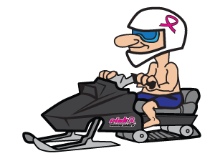
Men’s Radar Run Information:

How to participate
- Registration is free. Each participant will need to raise a minimum of $100.00 to compete.
- Your registration can be paid by you or by the pledges you raise.
- Your fundraising is unlimited and we hope you take part in raising pledges as this is the main idea of this event is to raise funds for those in need.

Schedule
- All participants need to check in at the track on Friday between 1:30pm to 2:30pm. With any additional funds turned in at that time. You can mail your pledges in prior to the event also (mail them at least 2 weeks prior to the event).
- All participants to the warming area/ trailer no later than 3:15pm. At that time, your sleds and 1 pit crew member will be directed where to stage your snowmobile.
- If you are aiming to go over 100mph you MUST wear a tek vest.

Fundraising
- Easier than you think! When you register online, you create a fundraising profile. You can send this profile out to others through email and your social media. Anyone can make a donation to you right there online. They receive a receipt right away!
- If you collect cash or checks, please make the checks out to: Pink Ribbon Riders
- Cash/ change - if you are mailing to us, please send your check or change into a money order.

